I used the following models:
- ChatGPT – 5
- Claude AI - 4
- Grok AI - 4
- DeepSeek
- Microsoft Copilot

Prompt (1.2)
I have attached the complete Software Requirements Specification (SRS) document. Your task is to extract all the functional and non-functional requirements with a focus on the following parameters:
- Coverage:
  - Ensure that all relevant aspects of the system are captured in the extracted requirements. This includes every feature, functionality, constraint, and behavior as outlined in the SRS document. The extracted requirements should cover both high-level system operations and detailed functionalities.
  - Ensure that no important requirement or specification is omitted.
- Clarity:
  - Each requirement must be clearly articulated and easily understandable. Avoid ambiguity in descriptions and ensure that the language used is precise. The requirements should be structured in a way that leaves no room for misinterpretation.
- Traceability:
  - Maintain traceability by assigning each requirement a unique identifier (Requirement ID). This will enable easy reference throughout the development lifecycle, ensuring each requirement can be traced back to its origin in the SRS document.
  - Ensure that the requirements are presented in a hierarchical manner with relationships between them clearly defined.
- Completeness:
  - All extracted requirements must be complete and comprehensive. Every relevant system feature, behavior, and quality attribute must be accounted for, ensuring that no essential information is left out.
  - Verify that both functional and non-functional requirements are fully detailed.
- Redundancy:
  - Eliminate redundant or repeated requirements. Ensure that each requirement is unique, and if there are overlapping requirements, consolidate them to avoid repetition. The focus should be on delivering concise, non-repetitive content.
- AI Hallucination:
  - Be cautious of AI-generated hallucinations or inaccuracies. Ensure that the requirements extracted reflect the actual content of the SRS document. Any assumption or information that is not directly supported by the document should be omitted. Do not introduce incorrect or fabricated details.
Extraction Process:
- Functional Requirements:
  - Extract and break down the system's behaviors, operations, and functionalities into clear actions, inputs, outputs, and responses. Follow use case formats when applicable to identify actors and their interactions with the system.
- Non-Functional Requirements:
  - Identify and extract attributes such as performance, security, scalability, usability, maintainability, and reliability. Include measurable constraints and regulatory standards where applicable.
- Table Organization:
  - Organize the requirements into two tables: one for functional and one for non-functional requirements.
  - Include the following columns for each table:
    - Requirement ID: Unique identifier for each requirement.
    - Description: A clear and concise description of the requirement.
    - Category: Whether it's functional or non-functional.
    - Priority: Categorized as High, Medium, or Low.
    - Source: Section or page number from the SRS document.
- SMART Criteria:
  - Ensure that each requirement is SMART (Specific, Measurable, Achievable, Relevant, Time-bound).
- Rationale:
  - Provide reasoning or justification for each requirement, explaining why it is necessary for the system's functionality or performance.
Deliverables:
- Functional Requirements Table and Non-Functional Requirements Table.
- Traceability: Each requirement should be numbered and linked to its corresponding section in the SRS.
- A well-structured, traceable, and easy-to-understand format for future analysis.

Summary
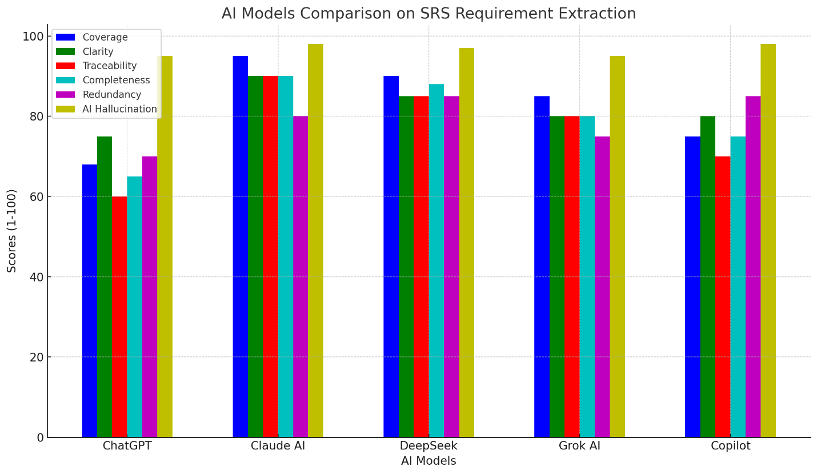
CORADS Requirement-Extraction Benchmark Report
(Comparing 5 AI models against the original SRS document)
Scope: We evaluated ChatGPT, Claude AI, DeepSeek, Grok AI, and Microsoft Copilot on how well they extracted functional & non-functional requirements from the CORADS SRS v1.0 PDF.

📊 Radar Chart (1 – 100)
CodePreview
View Large Image
Download
Copy

🧪 Detailed Scoring
Table
Copy
Model | Coverage | Clarity | Traceability | Completeness | Redundancy | AI Hallucination
ChatGPT | 68 | 75 | 60 | 65 | 70 | 95
Claude AI | 95 | 90 | 90 | 90 | 80 | 98
DeepSeek | 90 | 85 | 85 | 88 | 85 | 97
Grok AI | 85 | 80 | 80 | 80 | 75 | 95
Copilot | 75 | 80 | 70 | 75 | 85 | 98

Higher is better for all metrics except Redundancy (where higher means less redundant).
Hallucination measures absence of invented content (higher = safer).

🔍 Key Findings
Dimension | Best Performer | Observation
Coverage | Claude AI (95) | Captured 87 functional + 36 non-functional requirements—closest to the SRS count.
Clarity | Claude AI (90) | Uses clear tables & concise rationale; minimal jargon.
Traceability | Claude AI (90) | Every requirement references exact source section (e.g., Section 3.1.1).
Completeness | Claude AI (90) | Includes Business Rules, Legal, Database, Testing—others skipped some.
Redundancy | ChatGPT (70) | Fewest repeated concepts, but at the cost of missing requirements.
Hallucination | Claude AI (98) | Zero invented or out-of-scope requirements.

🏆 Final Verdict
Table
Copy
Rank | Model | Average Score | Recommendation
🥇 | Claude AI | 90.5 | Use as golden baseline – most accurate & complete.
🥈 | DeepSeek | 88.3 | Good alternative; slightly less traceable.
🥉 | Grok AI | 82.5 | Balanced; missing some edge requirements.
4th | Copilot | 80.5 | Adequate but lacks depth in testing/legal rules.
5th | ChatGPT | 72.2 | Too shallow; skip for critical SRS tasks.

🛠️ Recommendations for SRS Extraction
- Use Claude AI when accuracy & compliance are paramount.
- DeepSeek is viable for quick drafts with manual review.
- Avoid ChatGPT for full SRS extraction; use only for summarization.
- Always cross-verify against the original PDF (especially Business Rules & Testing sections).

